Part Number: PT936-60110-XX

PT936-60120-XX

PT936-60170-XX
Kit Contents
Item # | Quantity Reqd. | Description
1 | 1 | Front Driver Door Guard
2 | 1 | Front Passenger Door Guard
3 | 1 | Rear Driver Door Guard
4 | 1 | Rear Passenger Door Guard
Hardware Bag Contents
Item # | Quantity Reqd. | Description
1 | N/A
2
3
Additional Items Required For Installation
Item # | Quantity Reqd. | Description
1 | A/R | Distilled water (spray bottle)
2 | A/R | Lint-free towel
3 | A/R | Blue painter’s masking tape
4 | 1 | Scissors
Conflicts
None
Recommended Tools
Personal & Vehicle Protection | Notes
None
Special Tools | Notes
PPO Magnetic Template | IADS p/n =  GX412-D5-01
DIO Paper Door Templates | See last page of these  instructions
Nylon Removal Tool(NRT) | SST p/n =  00002-06002-01
Installation Tools | Notes
12-oz. rubber mallet | IADS p/n = PRI10-D5-02  Vaughn, P/N : SF12
Special Chemicals | Notes
Unisource Quic Solv Formula  or VDC Approved Degreaser | U22937 Degreaser
General Applicability
All
Recommended Sequence of Application
Item # | Accessory
1
2
3
*Mandatory
Vehicle Service Parts (may be required for reassembly)
Item # | Quantity Reqd. | Description
1
2
3
Legend
STOP: Damage to the vehicle may occur. Do not proceed until process has been complied with.
OPERATOR SAFETY: Use caution to avoid risk of injury.
CAUTION: A process that must be carefully observed in order to reduce the risk of damage to the accessory/vehicle and to ensure a quality installation.
TOOLS & EQUIPMENT: Used in Figures calls out the specific tools and equipment recommended for this process.
REVISION MARK: This mark highlights a change in installation with respect to previous issue.
SAFETY TORQUE: This mark indicates that torque is related to safety.

Care must be taken when installing this accessory to ensure damage does not occur to the vehicle. The installation of this accessory should follow approved guidelines to ensure a quality installation.

These guidelines can be found in the "Accessory Installation Practices" document.

This document covers such items as:-
- Vehicle Protection (use of covers and blankets, cleaning chemicals, etc.).
- Safety (eye protection, rechecking torque procedure, etc.).
- Vehicle Disassembly/Reassembly (panel removal, part storage, etc.).
- Electrical Component Disassembly/Reassembly (battery disconnection, connector removal, etc.).

Please see your Lexus dealer for a copy of this document.

Installation of Door Edge Guard (DEG)
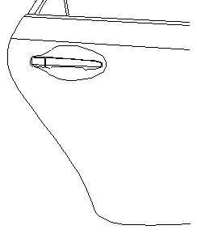
  - Fully open rear passenger door and clean and dry trailing edge of door as needed with distilled water and lint free towel. (Fig. 1-1)
NOTE: If being installed at Port, clean trailing edge of door with TMS approved U22937 Quic Solv degreaser or VDC approved degreaser. Finish cleaning with distilled water and lint free towel per instruction (a).
Trailing Edge
NOTE: If being installed at Port, all references to “template” refer to a magnetic template. If being installed by a dealer or individual, all references are to the paper templates located on the last page of these instructions.
Fig. 1-1
  - If you will be using the paper templates, please use scissors and carefully cut them out at this time.
NOTE: Templates are reversible for use on both sides of the vehicle.
  - Select rear door template and fit notch around door handle. Adjust as needed to ensure it is parallel to body line directly above the template. If needed, tape into place using painter’s masking tape. (Fig 1-2)
Fig. 1-2

  - Align top edge of the DEG, (labeled Rear Passenger) with lower edge of template alignment notch as shown.
NOTE: Top of DEG can be identified by matching the profile of DEG to the door profile. (Fig 1-3)
In some instances, the free form shape of the DEG may differ from exact physical door contours. Production tooling consideration for the DEG provides the channel with ‘memory’ to conform to the exact door contours as the channel is installed.
Fig. 1-3
NOTE: BEFORE PROCEEDING IT IS EXTREMLY IMPORTANT TO PROPERLY ALIGN THE DOOR EDGE, DOOR EDGE GUARD CHANNEL AND MALLET AS SHOWN IN FIG. 1-4
Fig. 1-4
  - While holding DEG in proper alignment with one hand, use soft side of the rubber mallet to begin tapping the channel onto the door edge, start three (3”) inches below the top of the DEG. (Fig. 1-5)
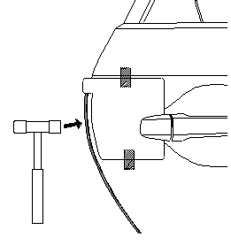
NOTE: If DEG needs to be removed for any reason, the DEG should be replaced with a new part. DEG employs compression fit design for retention and appropriate retention cannot be assured if DEG is reinstalled.

Recommended removal technique is with use of a Nylon Removal Tool (NRT). Begin by positioning the tip of the NRT against the leading edge of the DEG on the outside face of the door. Gently tap the NRT just below the top of the DEG to begin disengaging the DEG, and tapping progressively down the length of the channel until the DEG is completely disengaged.
Fig. 1-5

CAUTION: DO NOT PULL ON THE DEG; THIS CAN DAMAGE THE DEG AND THE FINISHED PAINT QUALITY. Recommended DEG removal procedure is described in NOTE above.
  - Continue tapping channel onto door edge moving toward the top of door then moving down the entire length of the DEG. Use your other hand to steady and guide DEG as you go. (Fig.1-6)
NOTE: IT IS IMPORTANT TO PROPERLY SEAT CHANNEL AS YOU PROCEED DOWN AND AROUND THE CURVES OF THE DOOR.

  - With DEG engaged the full length of door, begin at top and proceed tapping (use soft side of mallet) with moderate blows down entire length to ensure channel is fully seated.
Fig. 1-6
  - Once this is completed, carefully use firmer side of mallet to very lightly tap down the length of the DEG. If fully seated you should hear a solid report from the tapping.
NOTE: Intended purpose of this step is to listen for a solid report in response to light taps to confirm DEG is fully seated. THE FIRMER SIDE OF THE MALLET CAN DAMAGE THE DEG IF USED WITH MODERATE OR HEAVY BLOWS. If audible report received with light tap indicates DEG is not fully seated, repeat steps 1(g) and 1(h).
  - Carefully close rear door and ensure DEG has sufficient clearance from any adjoining body panel. Carefully remove template from door and retain for use on driver side. (Fig. 1-7)
Fig. 1-7
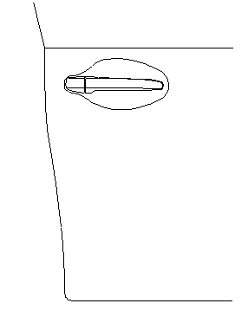
  - Fully open front passenger door and clean and dry trailing edge of door as needed with distilled water and lint free towel. (Fig. 1-8)

Trailing Edge

Fig. 1-8

  - Select front door template and fit notch around door handle. Adjust as needed to ensure it is parallel to body line directly above the template. If needed, tape into place using painter’s masking tape. (Fig 1-9)

Fig. 1-9

  - Align top edge of DEG (labeled Front Passenger) with lower edge of template alignment notch as shown. (Fig 1-10).

Fig. 1-10
  - While holding DEG in proper alignment with one hand (indicated by arrow), use soft side of the rubber mallet to begin tapping the channel onto the door edge. Start three (3”) inches below the top of the DEG working your way to the top of the DEG. (Fig 1-11)
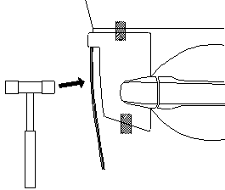
NOTE: If DEG needs to be removed for any reason, the DEG should be replaced with a new part. DEG employs compression fit design for retention and appropriate retention cannot be assured if DEG is reinstalled.
Fig. 1-11

Recommended removal technique is with use of a Nylon Removal Tool (NRT). Begin by positioning the tip of the NRT against the leading edge of the DEG on the outside face of the door. Gently tap the NRT just below the top of the DEG to begin disengaging the DEG, and tapping progressively down the length of the channel until the DEG is completely disengaged.

CAUTION: DO NOT PULL ON THE DEG; THIS CAN DAMAGE THE DEG AND THE FINISHED PAINT QUALITY. Recommended DEG removal procedure is described in NOTE above.

  - Once the top of the DEG channel is seated on door edge, continue tapping the channel onto door edge moving toward the bottom of the DEG. Use your other hand to steady and guide the DEG as you go. (Fig.1-12)
NOTE: IT IS IMPORTANT TO PROPERLY SEAT THE CHANNEL AS YOU PROCEED DOWN DOOR.
Fig. 1-12
  - With DEG engaged the full length of door, begin at top and proceed tapping with moderate blows (use soft side of mallet) down entire length to ensure channel is fully seated.

  - Once this is completed, carefully use the firmer side of mallet to very lightly tap down the length of the DEG. If fully seated you should hear a solid report from the tapping.
NOTE: Intended purpose of this step is to listen for a solid report in response to light taps to confirm DEG is full seated. THE FIRMER SIDE OF THE MALLET CAN DAMAGE THE DEG IF USED WITH MODERATE OR HEAVY BLOWS. If audible report received with light tap indicates DEG is not fully seated, repeat steps 1(o) and 1(p).
  - Carefully close front door and ensure DEG has sufficient clearance from any adjoining body panel. Carefully remove template from door and retain for use on driver side. (Fig. 1-13)
  - Repeat steps 1(a) thru 1(q) on the driver side of vehicle.
Fig. 1-13

Accessory Function Checks
Confirm all Door Edge Guards are fully seated.

NOTE: Use the yellow side of the mallet to ensure that the Door Edge Guards are fully/ properly seated.

Vehicle Function Checks

Vehicle door operation

Vehicle Appearance Check
After accessory installation and removal of protective cover(s), perform a visual inspection.

Look for a fairly consistent gap between the DEG and adjoining vehicle panels.

NOTE: Normal vehicle manufacturing tolerances may exist that are not a consequence of an improperly seated DEG installation.

Confirm all four vehicle doors open and close without interference from DEG.

Ensure no damage (including scuffs and scratches) was caused during the installation process.
(For PPO installations, refer to TMS Accessory Quality Shipping Standard.)

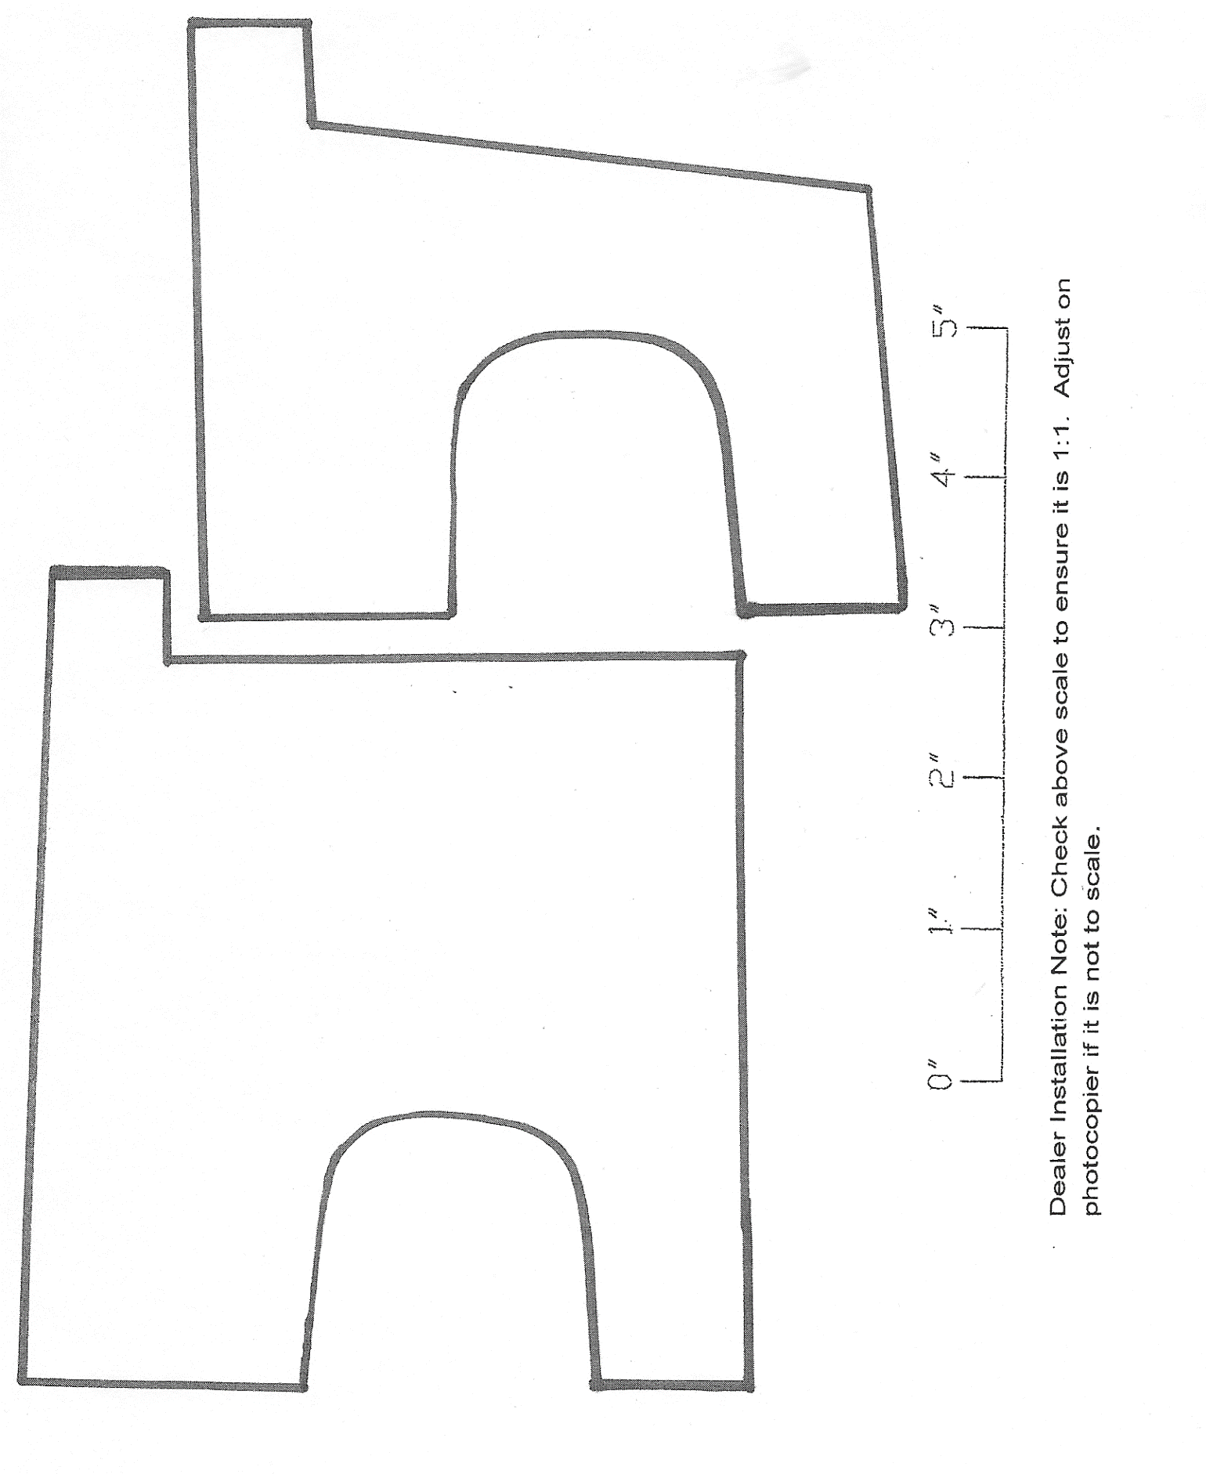
Place cut-out around door handle.
Place cut-out around door handle.
Lexus GX Front Driver Door Edge Guard Mounting Template. Use opposite side for front passenger door.
This edge should be parallel to body line.
Lexus GX Rear Driver Door Edge Guard Mounting Template. Use opposite side for rear passenger door.
This edge should be parallel to body line.
Place cut-out around door handle

